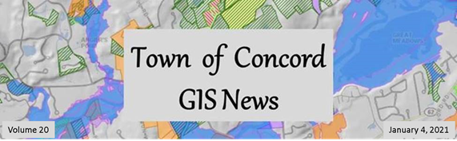

Happy New Year!

In This Issue

- Welcome Jason Bulger!
- CPW Work Order Management
- Concord Trail Guide
- Nearmap: October Survey
- Map Gallery

Back to Top

1. Welcome Jason Bulger!

 | My name is Jason Bulger, and I’m happy to have joined the Concord team in mid-November as the new Chief Information Officer. I have spent almost 10 years in the municipal IT world, and I’m excited to bring my experience and passion for a professional and service-based department to a community that cares so much about its residents, staff and natural resources.
I have long prioritized the advancement of GIS programs because I understand the value they lend to nearly every department. It is vital to ensure adequate funding so that data stays current and technological foundations are kept strong and up-to-date. It’s also important that staff, contractors and residents alike can make use of these systems as much as possible.

Everything I have seen about Concord’s GIS program demonstrates a strong commitment to these values, and I’ll be pleased to continue that tradition. We have amazing GIS staff and have made many dramatic improvements in the last few years. If you or anyone in your department has specific GIS or mapping needs that are currently unmet, please feel free to reach out to me or Jill so we are aware of it and can begin working with you.

I’m excited to start diving deeper into the world of Concord GIS!

Back to Top

2. CPW Work Order Management

The Highway and Grounds division of Concord Public Works has had no systemic method to assign and track daily work processes, manage resident requests, organize previous and future required asset inspections, and schedule routine fleet and building maintenance. CPW GIS has been working with GIS consultant Ray Corson to customize a map-based work order and asset management system to address these needs.

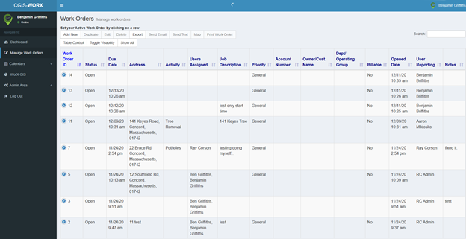

The Work Order management page above is the central hub for creating, searching, exporting, and organizing work orders. All current and past work orders can be filtered and organized based on column, and actions can be taken such as texting or emailing the work order directly to personnel.

 | At right is an example of a new work order that would be entered in by administrative staff.  Typically, a resident will call Public Works directly to report an issue and a work order will be generated based on this request.  Once the admin enters the required information, it will show up on the supervisor’s calendar and they can then assign the work order to a field crew member. This work order will appear as “active” (red symbol) in the map viewer below. | 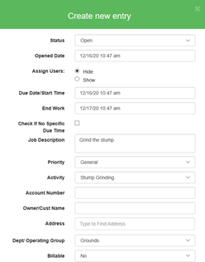
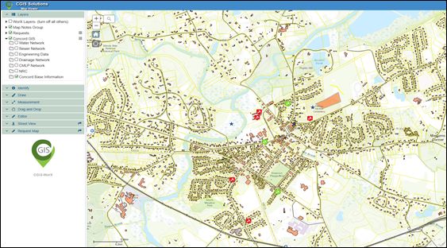

The map viewer within the Work Order system utilizes Public Works asset data directly from the Town’s GIS server, which ensures the Town has full control of all information. Public Works GIS data can be toggled on and off, with the ability to view current and past work orders at the same time. Since this data is being fed directly from Concord’s GIS server, all data is being shown in real-time so there is no delay in updating information. Administrative staff and work crew members are eager to get started in leveraging this new technology to increase communication and efficiency throughout the department.

- Ben Griffiths, GIS Technician

Back to Top

3. Concord Trail Guide

Working with local residents, the Natural Resources Division is developing a trail book that highlights the ecology and history of Concord’s treasured open spaces. Concord GIS is assisting by updating existing maps and developing displays specific to this publication. These include a town-wide overview map (draft shown below) as well as a trail map for each of the 14 featured properties.
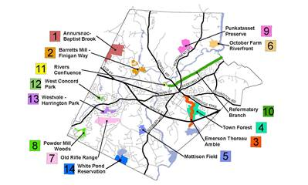
The book and maps also identify Key Sites to Visit for each property, information which has never before been compiled in one place for public reference.
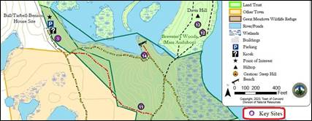
I’m looking forward to field-testing the finished product!

Back to Top

4. Nearmap October Imagery

Our Nearmap aerial imagery subscription has been updated with a new survey, flown on October 4. Here are some views you may find interesting. You can browse this imagery near the bottom of our GIS homepage.

Cambridge Turnpike
As of July this road project was still digging for a solid footing at Mill Brook:
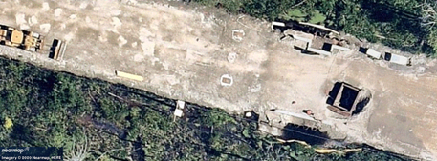
October’s survey shows the solution in progress:
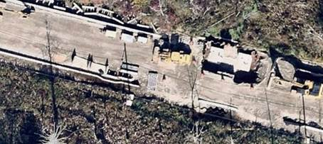

Bruce Freeman Rail Trail
Footings have been poured for the bridge over Nashoba Brook, just south of Route 2.
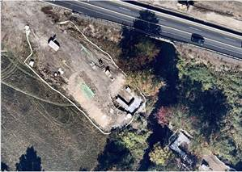

Middlesex School
Between the July and October surveys, some temporary housing popped up in a parking lot at the Middlesex School.
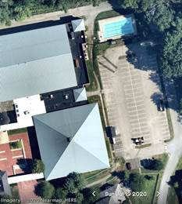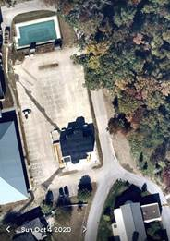

Back to Top

5. Map/App Gallery

CTRL-Click on a thumbnail to view a full-size map
Voter Precinct Map and WebMap | 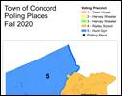 | Developed an updated-for-COVID Voter Precinct map poster for Kaari T to post at polling places, as well as an embeddable webmap for her Elections and Voting webpage. The webmap includes links to addresses and photos for each polling place.
Market Areas |  | Each year our Assessor reviews comparable home sales and determines, for each of over a dozen areas in town, a neighborhood adjustment factor for valuation purposes. The Market Areas map shows neighborhoods and adjustment factors – and is quite colorful too.
Visitor Center Street Map | 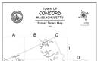 | Beth Williams in Recreation requested a street map handout for the Visitor Center – a fine idea, so our visitors stay found while in town!
Punkatasset  Trail Map | 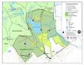 | As noted above, a full set of trail maps is under development; here’s a sample.

Back to Top

